VISVESVARAYA TECHNOLOGICAL UNIVERSITY
"Jnana Sangama", Belgavi-590 018, Karnataka, India

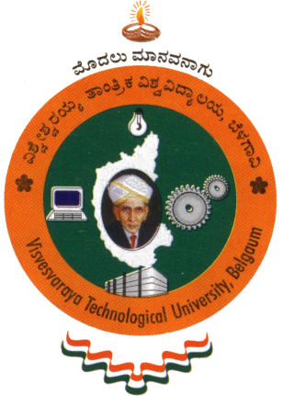

A DISSERTATION REPORT
On
Smart Energy Efficient Home Automation System Using IoT
Submitted in Partial Fulfillment of the requirement for the award of the degree of

BACHELOR OF ENGINEERING
IN
COMPUTER SCIENCE AND ENGINEERING

Submitted By
Bareddy Suma Reddy 1SJ16CS016
Anirudh Kumar Mahato 1SJ16CS007
Anubhav Guptabhaya 1SJ16CS010

Carried out at
B G S R&D Centre,
Dept of CSE,
SJCIT

Under the guidance of
Prof. Apoorva S
Assistant Professor
Dept. Of CSE
SJCIT


S.J.C.INSTITUTE OF TECHNOLOGY
DEPARTMENT OF COMPUTER SCIENCE AND ENGINEERING
CHIKKABALLAPUR-562101
2019-2020

